LAB 9
2019F_ESE 3014_1

GROUP 16 -

FRANCIS VIJITH A J– C0742980
VIJAYAPRAKASH V I – C0744450

Set up and achieve SPI interfacing communication for BBB as master andADXL345 Accelerometer as slave.

Checking the BB-SPI.dtbo files.
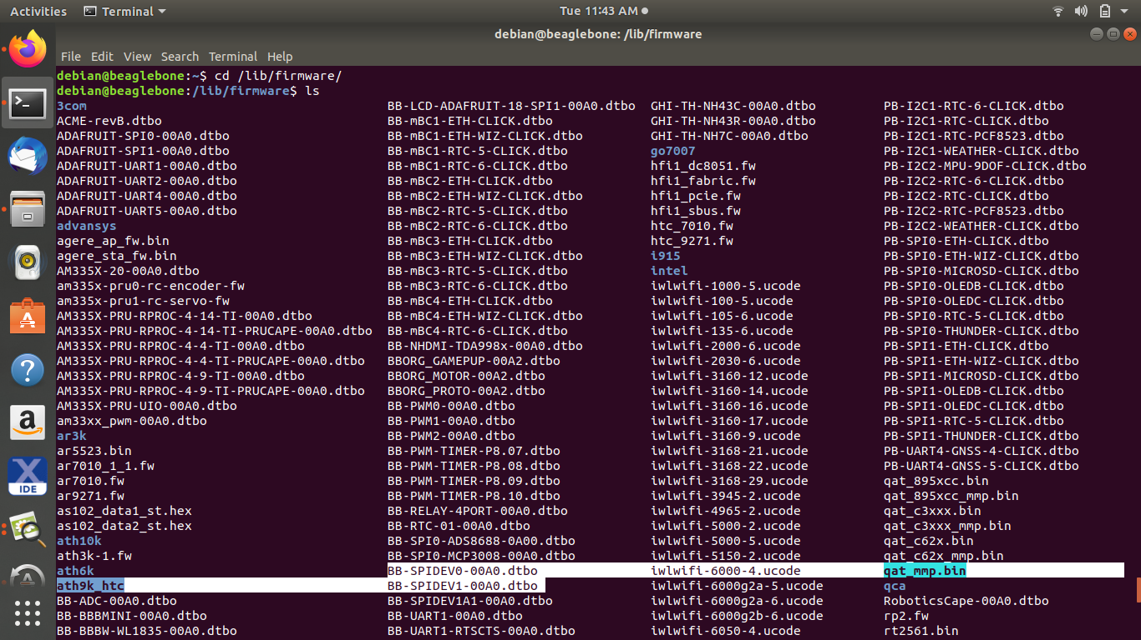
Editing the uEnv.txt file in /boot in nano editor to enable the SPI pin configuration

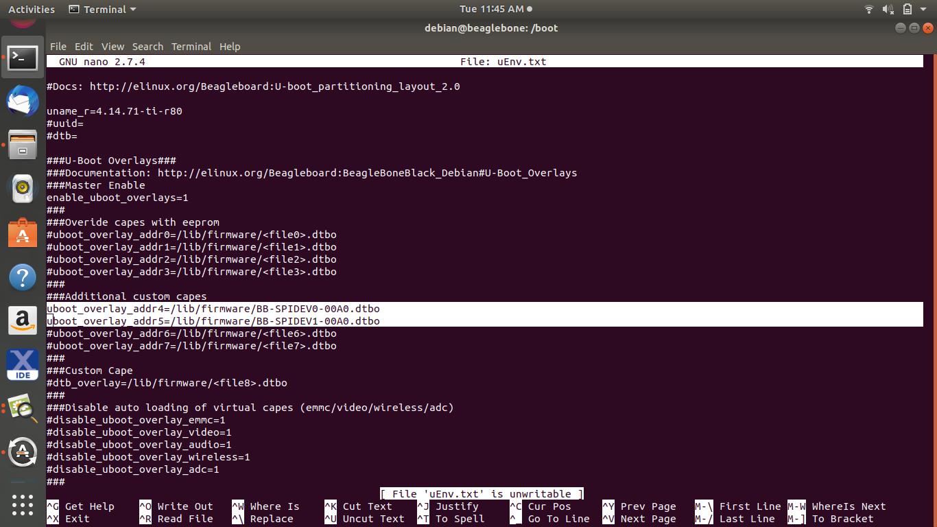
Disabling the HDMI
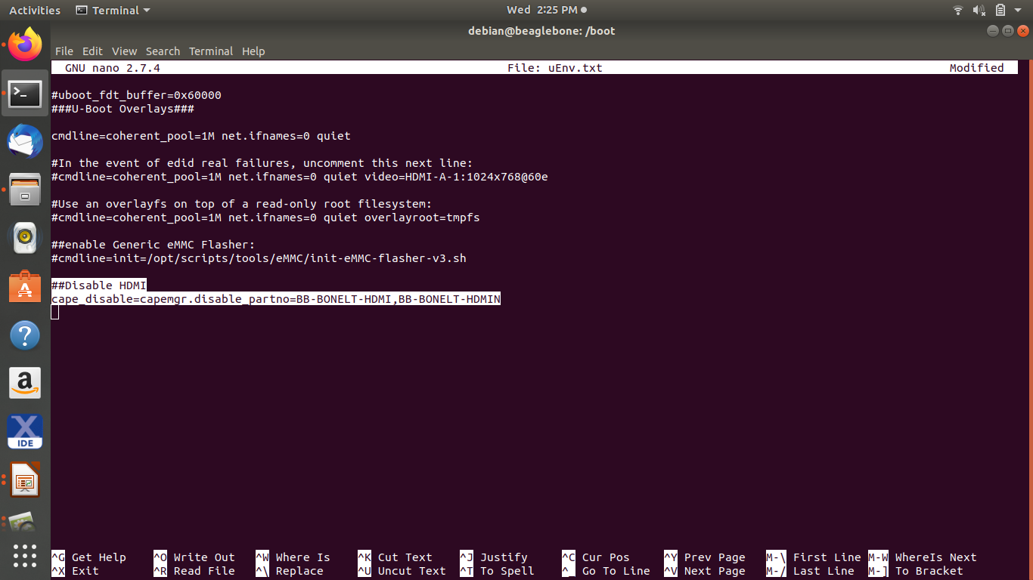
Checking for SPI pins
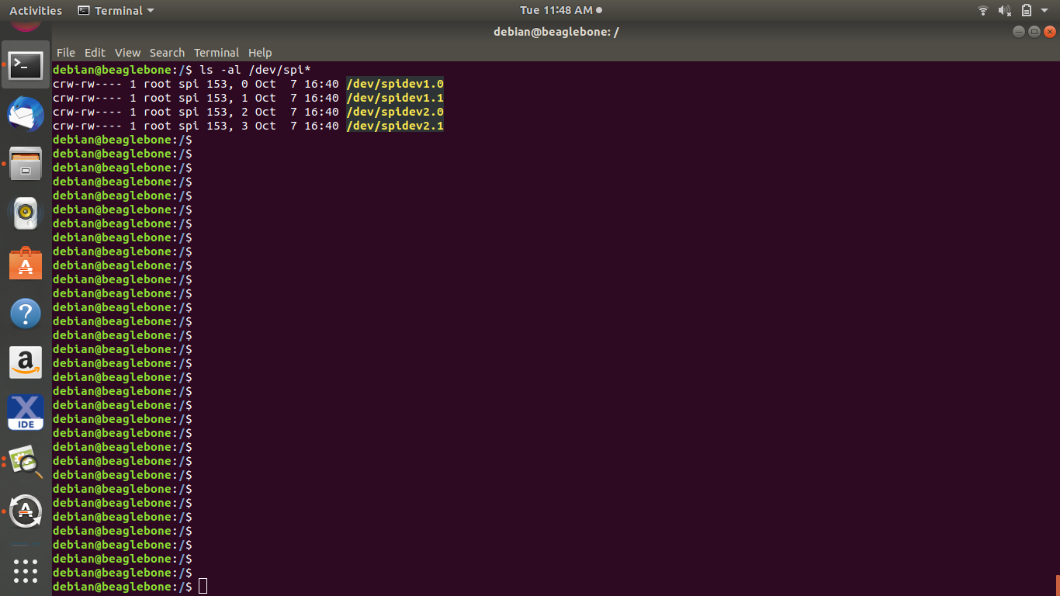

Testing the SPI pins with a c program SPIdev_test and changing the position of the accelerometer
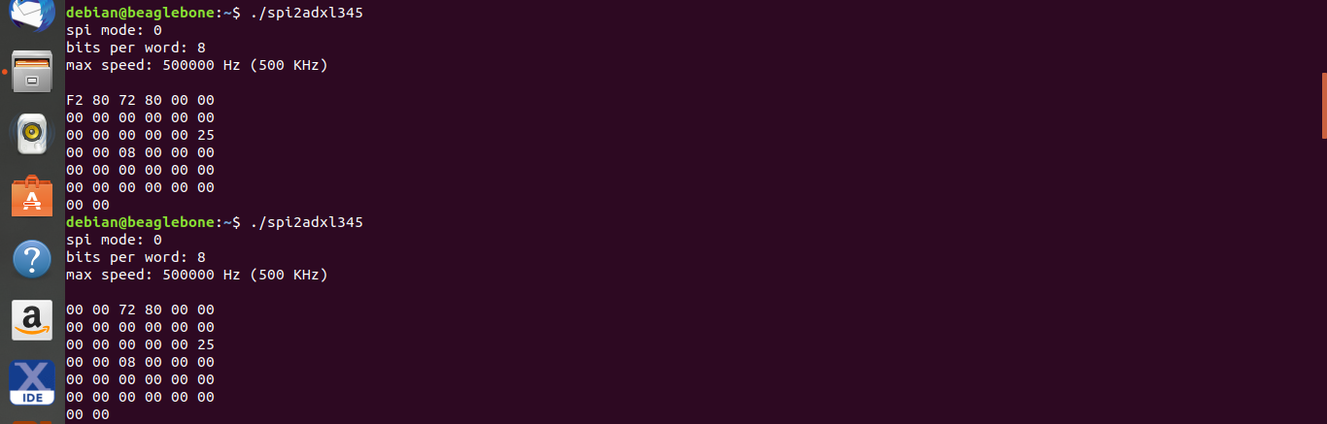

There is a change in values returned when spi2adxl345.c is executed.

The link for the working video is given:

https://www.youtube.com/watch?v=vGGvGrKebbE

